Integration – Rectangle Rule Exercise

1. In addition to the left rectangle rule, there is also a ***right*** rectangle rule. The right rectangle rule says that we should approximate the integral by forming rectangles using the height at the ***right*** edge of each interval. Suppose that we wish to approximate  using the **right** rectangle rule. Answer the following questions by drawing on the diagrams (on your printout).
   1. Draw the exact desired integral on the diagram below (graphically – no calculations):

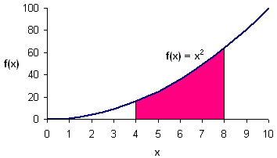

* 1. With one rectangle for the approximation, what is our estimate? Show the rectangle on the diagram below. Show your calculations to the right of the diagram (or separately).

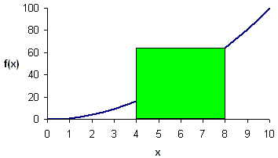

*Right rectangle rule:* f(8) * 4 = 64 * 4 = **256**

*Left rectangle rule:* f(4) * 4 = 16 * 4 = 64

* 1. With two rectangles for the approximation, what is our estimate? Show the rectangles on the diagram below. Show your calculations to the right of the diagram (or separately).

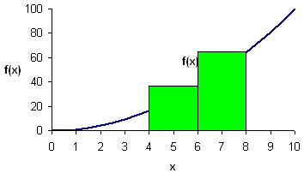

*Right rectangle rule:* f(6)*2 + f(8)*2 = 36*2 + 64*2 = 72 + 128 = **200**

*Left rectangle rule:* f(4)*2 + f(6)*2 = 16*2 + 36*2 = 32 + 72 = 104

* 1. With four rectangles for the approximation, what is our estimate? Show the rectangles on the diagram below. Show your calculations to the right of the diagram (or separately).

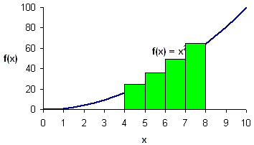

*Right rectangle rule:* f(5)*1 + f(6)*1 + f(7)*1 + f(8)*1 = 25 + 36 + 49 + 64 = **174**

*Left rectangle rule:* f(4)*1 + f(5)*1 + f(6)*1 + f(7)*1 = 16 + 25 + 36 + 49 = 126

* 1. If we use the ***right*** rectangle rule to estimate the integral for a function that is increasing throughout the desired interval (such as *f*(*x*) = *x*2 from 4 to 8), will the estimate be above or below the true value? Explain why.

Too high – always using the largest value of the function in each range

*Note that the correct answer is 149.3333…*

* 1. If we use the ***left*** rectangle rule to estimate the integral for a function that is increasing throughout the desired interval (such as *f*(*x*) = *x*2 from 4 to 8), will the estimate be above or below the true value? Explain why.

Too low – always using the smallest value of the function in each range